**Lecture 24 – Reproductive System**

In this lecture, you will learn about the concept of reproduction and various organs involved in human reproduction. You will also learn how endocrine system controls human reproductive physiology.

* Reproduction is a process of producing “offspring” from “parents.”
  + (Asexual) reproduction: generation of new individuals without the fusion of egg and sperm (example: fission, budding, parthenogenesis)
  + (Sexual) reproduction: fusion of haploid gametes forming a diploid cell, called the (zygote).
* Sexual reproduction has both cost and benefit
  + Advantage: creation of (genetic variation), recombination, DNA repair
  + Disadvantage: only one sex can bear young, males and females must search each other, only half of genes is passed on.
* Gametes are (haploid) reproductive cells 🡪 miosis
  + Sperm: produced by male, small, motile, hundreds of millions produced each day
  + Egg: produced by female, large, nonmotile, one egg produced per month (~500 lifetime)
  + So, which one is more valuable?
* Reproductive organs have sex-specific roles
  + Male reproductive organs: produce (sperm), stimulate female, transfer sperm to female
  + Female reproductive organs: produce (egg), fertilize egg, nurture fertilized egg, deliver zygotes or nurture embryos
* Animal reproductive structures are highly diverse
  + Spiders have (pedipalp), which is the modification of the appendages.
  + Ducks have (cornsterm penis) , which travels through convoluted female reproductive tract.
  + Snakes have (hemipenis).
  + Most mammals have (bawlum), which is a bone inside penis. Humans don’t have it.
* You need to know various organs and their functions in human reproductive system. This information can also be found in p.1002-1005.
  + - Figure 46.70
  + Female:
    - Ovaries: for egg production
    - Oviduct: tube, egg travels
    - Uterus:
    - Endometrium: uterus – internal wall, inner lining at uterus
    - Vagina: muscular & elastic chamber, site for penis insertion and sperm deposition
  + Male:
    - Testes: sperm produced / gonnads consists of many highly coiled tubes
    - Epididymis: site for sperm maturation
    - Vas deferens: muscular suct
    - Seminal vesiscle: produce mucus, fructose, coagulating enzyme, ascorbicacids
    - Prostate gland: prostaglanders
    - Bulbourethral gland: produce clear mucus
    - Last three protect the sperm
* Male and female reproductive systems have several homologous structures
  + (ovaries) and (testes)
  + (clitoris) and (penis) 🡪 erectile tissue
* Gametes are produced by meiosis. Review what meiosis is. (Fig. 13.7)
* Spermatogenesis: production of male gametes (Fig. 46.12)
  + Continuous production in male from puberty to death
  + About 7 weeks to mature
  + ~160 million sperms in each ejaculate
  + Under right conditions, sperms can survive about 5 days in female
  + (sertole) cell nourishes sperm cells throughout spermatogenesis.
  + Testes produce sperm in highly coiled tubes called (seminiterous tubules).

Primordial germ cell [2n] 🡪 (spermatogonual) 🡪 Spermatogonia [2n]🡪

(spermatocycle) 🡪 Spermatid [n]🡪 (sperm cell)

* + You need to know when meiosis occurs during spermatogenesis.
* Oogenesis: production of female gametes (Fig. 46.12)
  + A prolonged process that takes decades
  + Immature eggs form in the ovary of the (female embryo), but do not complete until (sexual reproduction).

In Embryo:

Primordial germ cell [2n] 🡪 (oogonia) 🡪 Primary oocyte [2n]

At puberty:

Completion of meiosis I to result in (secondary oocycle), but the development is arrested at metaphase of meiosis II.

One cell degrades into (ogle).

After fertilization (addition of sperm):

Completion of meiosis II to result in (fertile egg).

One cell degrades into ( ).

* Differences between spermatogenesis and oogenesis
  + Spermatogenesis
    - All (four) products of meiosis develop into gametes
    - Mitotic division occurs throughout adolescence and adulthood
    - Mature sperms produced from precursor cells without interruption
  + Oogenesis
    - (unequal meiosis) resulting in a single gamete
    - Mitotic division completed before birth and gametogenesis ceases at about age 50
    - Mature eggs produced from precursor cells with (cory intermuption).
* Human reproductive system is under hormonal control. You need to know what hormones are involved in what developmental processes.
  + Gonadotropin-Releasing Hormone (GnRH): produced in (hypothalamus)
  + Luteinizing Hormone (LH): produced in ( )
  + Follicle-Stimulating Hormone (FSH): produced in ( )
  + Testosterone: produced in ( )
  + Estradiol and Progesterone: produced in ( )
* Hormonal control of male reproductive system (Fig. 46.14)
  + (FSH) and (LH) are required for normal spermatogenesis.
    - FSH: promote activity of Sertoli cells
    - LH: regulate Leydig cell
    - Inhibin: produced by Sertoli cell, acts on anterior pituitary to reduce FSH secretion
    - 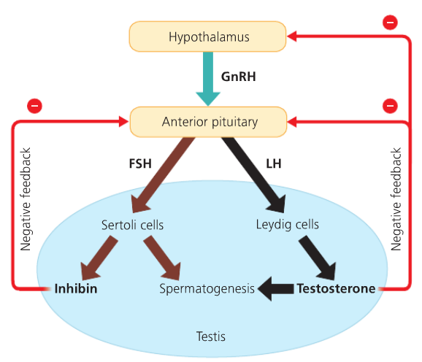Testosterone secretion and spermatogenesis occur continuously from puberty onward
* 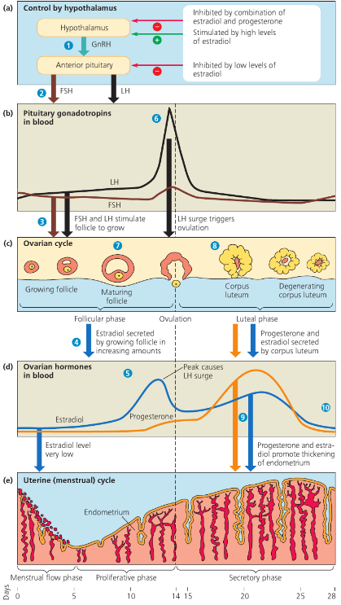Female reproductive cycle (Fig 46.13)
  + (ovarlian) cycle: follicles mature, ovulation, corpus luteum degenerates
  + (uterine) cycle: changes in uterus (thickening and shedding of endometrium) (28 day cycle)
* Hormonal control of female reproductive cycle. You need to know the intricate dynamics between hormone levels, ovarian cycle and uterine cycle. (Fig. 46.14)
  + Key hormones are:
    - GinRH
    - LH
    - FSH
    - Estradiol
    - Progesterone